**MGT559F- Leading in a Circular Economy**

**End-of-Course Assessment - January Semester 2023**

**Submission date: 19/04/2023**

SRUTHI MADHUSUDANAN

Table of Contents

Global e-waste generation 4

Linear to circular economy 5

Current circularity state of electronic sector in Singapore 6

Zero Waste Nation master plan (2019) 6

• **RENEW(REcycling Nation’s Electronic Waste) programme (2012** 6

• **ReCYCLE** 7

Extended Producer Responsibility scheme (2021) 7

• **Repair Kopitiam** 8

• **#EWASTENOMORE challenge** 8

Upstream controls (NEA, n.d.) 8

• **Restriction of hazardous substances for electrical and electronic equipment** 8

• **Fluorescent lamps and compact fluorescent lamps (CFLs)** 8

• **Batteries** 8

The NEA's National Voluntary Partnership (NVP) (2015) 9

Minamata Mercury Convention 9

The NEA's Circular Economy Business Model Programme (CEBMP) 9

Barriers, enablers and accelerators for circular economy 10

Barriers 10

Enablers 11

**Using fruit peels to turn old batteries into new ones** 11

**Project Homecoming** 11

Accelerators 12

**Policy and legislation** 12

**Collaborative initiatives and partnerships** 12

**Certification and assessment** 13

Recommendations for implementing tools/initiatives/policies to accelerate circular economy in electronic sector 13

Specific collection targets 13

National fund for e-waste recycling 14

**Germany's ElektroG (Electronics and Electrical Equipment Act) policy** 14

Eco-point Incentive Program 14

Take-back program and discounts 14

**Japan’s Eco point Incentive Program** 15

References 15

SINGAPORE AND ITS ELECTRONICS SECTOR

The electronics industry, which contributes 8% of Singapore's GDP, is a major economic driver. The overall value of fixed asset investments in 2020 was S$17.2 billion, with investments in electronics accounting for more than 38%. (MOE, 2023). Humanity’s insatiable desire for technology has resulted in the world’s fastest growing waste stream, referred to as e-waste tsunami by the UN. (WorldEconomicForum, 2019) .With a population of 5.64 million utilizing electronic devices at a rapid rate significant amounts of electronic waste (or "e-waste") is generated annually. Singapore produces over 60,000 tonnes of e-waste each year

The UN defines e-waste as **“Any discarded product with a battery or plug, and features toxic and hazardous substances such as mercury, that can pose severe risk to human and environmental health”.**

Global e-waste generation

The weight of all EEE used worldwide rises by 2.5 million metric tonnes annually on average (Forti et al., 2020). According to some projections, the worldwide consumer electronics market is valued at US$1.1 trillion and is expected to increase at a 6% annualy until 2024. (Zion, 2018). The other side of this rising consumption is "e-waste," because of their short lifespans, rapid obsolescence, and lack of readily available repair solutions.

Only 17.4% of the 57.4 million tonnes(UN Global E-waste Monitor report,2023 ) of manufactured e-waste that was generated in 2021 was properly collected and recycled, indicating that the majority of e-waste is dumped without considering any recycling procedure and detrimental effects on the planet’s ecology.

Based on 2017 study, researchers estimated that smartphone production generates between 40 to 80 kg of CO2, equivalent to driving a typical passenger car for 320 km. (CNA, 2021)

Figure 1 : Global e-waste generation annually

Figure 2 : Overall total non-recycled e-waste on earth

# Linear to circular economy

A more sustainable system must replace the "take, manufacture, and trash" linear approach for electronics. Every stage of a product's life cycle must be transformed in order to move toward a circular economy. Designing products differently is necessary, incorporating reuse and effective recycling requirements from the start.

Figure 3 : Circular vision for electronics

# 1a) Current circularity state of electronic sector in Singapore

Singapore’s annual e-waste stands at 60,000 tonnes, equivalent to 70 devices per person (NEA, Electronic Waste, n.d.). Hibernating devices are becoming increasingly prevalent as disposable money rises and obsolete equipment is replaced frequently. By 2035, Pulau Semakau, Singapore's only landfill, will be completely full. Singapore has taken a proactive stance and established a comprehensive system that includes legal measures, public education programs, and infrastructure development to ensure that e-waste is disposed of securely and ethically. Since that e-waste is one of the primary contributors to environmental damage, e-waste treatment is an essential step to restore the environment's quality. E-recycling also helps minimise carbon and methane emission and reduce production waste. (KGS, n.d.)

Figure 4 : Singapore’s e-waste

Singapore have taken the following initiatives to enable circularity in Electronics sector

## **Zero Waste Nation master plan (2019)**

The government released the Zero Waste Masterplan in 2019, with the goal of developing a "Zero Waste Country" by sustainably managing trash and resources.

Aim: To reduce the amount of waste by 30% by 2030, e-waste has been identified as an important focus. (Yuet, 2022)

**RENEW(REcycling Nation’s Electronic Waste) programme (2012)**: Launched in 2012 in collaboration with the organizations TES-AMM, DHL, and Star Hub. As of March 2019, there were more than 500 bins distributed across more than 400 places on the island for the collecting of e-waste. (Teo, 2020).

Figure 5 : RENEW e-waste collection bins

**ReCYCLE**: A joint venture by SingTel and SingPost launched in 2017 which encourages consumers to drop off their unwanted electronics devices at SingTel shops and SingPost branches, or mail them for free .

In July 2021, Singapore’s first ever nationwide e-waste management system was launched

**Extended Producer Responsibility scheme (2021)**: The EPR system is by product of Resource Sustainability Act (RSA), managed by the NEA. Producers take accountability for the collection and treatment of their products when they reach end-of-life.ALBA E-waste Smart Recycling Pte Ltd has been appointed as the Producer Responsibility Scheme (PRS) Operator for a five year period starting JULY 2021, to collect regulated consumer electrical and electronic waste across Singapore for recycling and proper treatment on behalf of producers (NEA, n.d.). Regulated consumer e-waste comes under this . ALBA has collected 3500 tonnes of e-waste since 2021 under this scheme. Over 300 large electronics retail outlets assists in-store e-waste collection services. As a part of the scheme, between July and November 2021 , 2,400 tonnes, of e-waste has been collected by ALBA. (Tan A. , 2021)

Figure 6 : E-waste management system by 2021

**Repair Kopitiam**: A community-based effort by NEA tries to change customers' perspectives on sustainability. Residents receive free instruction from volunteers on how to fix their broken electronics.

**#EWASTENOMORE challenge**: Organised by NEA with SGTECH, encourages citizens to invent a new products from broken electrical appliances

## 

## **Upstream controls (NEA, n.d.)**

**Restriction of hazardous substances for electrical and electronic equipment** :To reduce the negative effects of e-waste on the environment, the RoHS has been implemented in EEE.6 hazardous compounds that are allowed to be present in certain types of EEE are limited by the control measures, with effect on 1 June 2017. By reducing the amount of heavy metals entering our waste stream and improving the likelihood of recycling incinerator ash, this will extend the Semakau Landfill's useful life.

**Fluorescent lamps and compact fluorescent lamps (CFLs)** : Since 1 July 2012, only lamps with low mercury levels (less than 10mg for straight and circular lamps, less than 5mg for CFLs) have been permitted to be imported for use in Singapore. Such lamps, in accordance with environmental standards, can be safely disposed of alongside general waste at waste-to-energy incineration plants**.**

**Batteries**: Singapore has imposed mercury content restrictions on mercury oxide, zinc carbon, and alkaline batteries since 1 June 1992. Local sales of batteries with more than the specified mercury content are prohibited. To reduce the amount of discarded batteries, the use of rechargeable batteries is encouraged. Only laptop and mobile phone battery recycling services are currently present. Lead-acid batteries are considered Toxic Industrial Waste and are handled accordingly.

**The NEA's National Voluntary Partnership (NVP) (2015)** : Promotes the recycling and repair of used non-regulated household electrical and electronic items. Under the NVP, industry partners are encouraged to launch projects that promote safe disposal and reuse, thereby moving the electronics industry toward sustainable practices and a circular economy.

**Minamata Mercury Convention**: Starting March 31, 2018 Singapore has banned all batteries containing over 5 ppm mercury by weight. Similarly mercury-added products like fluorescent lamps, exceeding specified thresholds and non-electronic measuring devices, are phased from January 1, 2020. (Singapore, undated) .

**Carbon Tax** : On 1 January 2019, the first carbon pricing scheme in SEA was introduced. For the first five year period between 2019-2023,carbon tax was set at S$5/tCO2e to give emitters time to adjust. Keeping our net zero goal in mind, the carbon tax will be raised to S$25/tCO2e in 2024 and 2025, and S$45/tCO2e in 2026 and 2027, with the goal of reaching S$50-80/tCO2e by 2030. NCCS (n.d.)

Figure 7 : Carbon Price

**The NEA's Circular Economy Business Model Programme (CEBMP)**: This initiative encourages businesses to adopt circular business models such as leasing or product-as-a-service, and provides businesses with support and funding for transition. The CEBMP promotes alternative consumption and ownership models in order to reduce waste and encourage product reuse.

Based on a study conducted in April 2016 to October 2017, only 6% of e-waste (60,000 tons) were recycled, equating to 3,660 tonnes. Through consistent efforts by government , public and numerous stakeholders. Singapore’s recycling rate was increased to 52% in 2020.

# 1b) Barriers, enablers, and accelerators for circular economy

## **Barriers**

**

## **Enablers**

**Using fruit peels to turn old batteries into new ones :** SCARCE has developed a method of using orange peel waste to extract metals from old lithium-ion batteries. A combination of powdered, oven-dried orange peel and citric acid could successfully extract about 90 per cent of cobalt, lithium, nickel and manganese. The recovered metals were used in new lithium-ion batteries, which were found to have a similar charging capacity to commercial ones. The scientists are currently working on scaling up the metal recovery process and improving the battery's cycle life to make it viable for commercial use. (Tan C. , 2020) . Enabler : Technologies deployed -Material science , Energy storage and utilization, Bio-based material

**Project Homecoming :** Program for recycling printer ink and toner cartridges was started in Singapore in December 2011. The project is supported by The National Environment Agency (NEA) and spearheaded by NLB. Goal is to promote cartridge recycling and raise general awareness about the importance of recycling. The initiative makes recycling bins easily accessible for the public to properly dispose of their ink and toner cartridges. The raw materials recovered from cartridge recycling are then used to manufacture new products such as pens, promoting a circular economy – Enabler : System Thinking. (DELL)

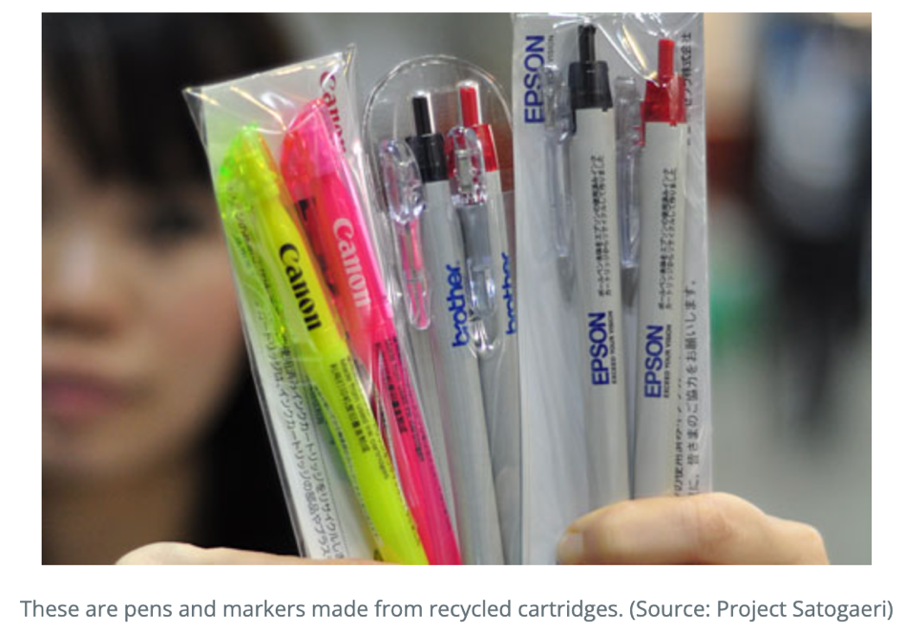

Figure 8 : Recycled pens and markers

## 

## **Accelerators**

### **Policy and legislation**

**SS 587 :** On 24 September 2013, Information Technology Standards Committee (ITSC) approved SS 587, a voluntary Singapore Standard for the management of end-of-life ICT equipment, on behalf of the Standards Council of Singapore. This standard provides organizations with a recognized framework to manage end-of-life ICT equipment responsibly. (Standards, n.d.)

**The Resource Sustainability Act (RSA 2019) :** RSA seeks to promote sustainable resource use and waste reduction in three key areas: e-waste, packaging, and food management. Producers and importers of regulated products must take accountability for their product's life and its associated environmental impact and implement waste reduction and recycling measures.

### **Collaborative initiatives and partnerships**

**Green Electronics Council (GEC)** (GEC, n.d.): The NEA is a member of the GEC, a global non-profit organization that promotes sustainable electronics by developing environmental standards and certification programs. The council collaborates with governments, industry, and non-governmental organizations to promote sustainable practices in the electronics industry. (Recyclingtoday, n.d.)

**Singapore CEA Alliance for Research in Circular Economy (SCARCE)(2018) :** A joint lab between NTU Singapore and the French Alternative Energies and Atomic Energy Commission (CEA).

**Aim:** To develop new, energy-efficient methods for recovering and recycling elements from e-waste. Their research focuses on recovering usable metals such as cobalt, nickel, and lithium from discarded lithium-ion batteries for use in new batteries. They also want to use environmentally friendly processes to segregate and recover ceramics, metals and organic materials from printed circuit boards. The lab is investigating advanced separation and extraction methods that uses less energy and are less hazardous.

### **Certification and assessment**

**EPEAT (Electronic Product Environmental Assessment Tool) :** Singapore is the 41st country to make the EPEAT electronics rating system available to buyers. EPEAT, A comprehensive voluntary sustainability ecolabel assists buyers in identifying more sustainable technology products and services. EPEAT is managed by GEC (globalecolabelling, n.d.)

**SS 587 :** A certifiable management system standard in consistency with other internationally recognized management system standards like ISO 14001. It follows Plan-Do-Check-Act method of continuous improvement.

.

# 1c) Recommendations

1. **Specific collection targets** :Singapore could establish specific collection targets for different types of e-waste to increase the e-waste recycling rate
2. **National fund for e-waste recycling :** Where manufacturers and importers contribute to a fund for management and disposal of e-waste. This would ensure sufficient funds are available for the e-waste recycling and dispoasal (UNU-ISP, 2011).

**Germany's ElektroG policy** : Implemented in 2005, ElecktroG is a framework for e-waste management in Germany. Since then, the policy has been updated and amended to meet rising needs of waste management , with the most recent being 2020. The ElektroG policy exemplifies how Singapore could set specific collection targets and create a national fund for e-waste recycling for increasing the overall recycling rate. Over the last three years, ElektroG policy has set a collection target of minimum 45% of the average EEE weight on the market.

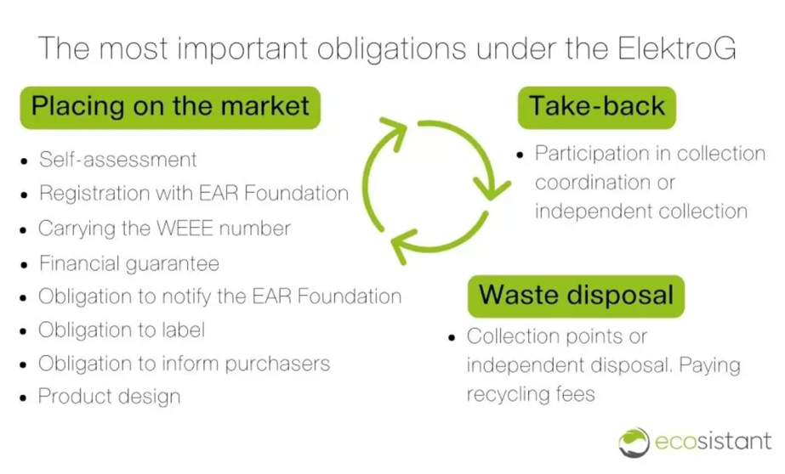

Figure 9 : Germany's ElektroG

1. **Eco-point Incentive Program :** The government could encourage consumers to buy environmentally friendly products by offering Eco-points that can be redeemed for rewards. The number of Eco-points awarded could be determined by the product's score and value.
2. **Take-back program and discounts** : Singapore could implement an electronic product take-back program for products reaching its shelf life. Participants in the program may receive additional Eco-points or other benefits, such as discounts on their next purchase. This would help to reduce e-waste and promote circularity via electronic product recycling and repurposing.

**Japan’s Eco point Incentive Program :** Established in May 2009, the program is supported by 290 billion yen in public financing till March 2010, and each Eco Point is worth one yen. While customers flocked to retailers to purchase eco-friendly equipment, the campaign increased replacement demand. Government standards for rating the products' energy efficiency served as the basis for choosing the products. The rating was based on a scale of one to five stars: The only way to earn eco-points was to buy items with four or more stars. (Eco-point incentive program In Japan, 2019). The Japanese government has estimated reduction of about 2,700,000t-CO2/year due to this programme.

# References

NEA. (n.d.). Electronic Waste. Retrieved from https://www.towardszerowaste.gov.sg/ewaste/

Yuet, W. H. (2022, may 31). Retrieved from GovInsider: https://govinsider.asia/intl-en/article/how-singapore-is-working-with-industry-players-and-citizens-to-recycle-electronic-waste-nea-ron-wong

Teo, A. (2020, october). Centre for liveable cities. Retrieved from Starting a Circular Economy in Singapore From Zero Waste: https://www.clc.gov.sg/research-publications/publications/digital-library/view/circular-economy-in-singapore-from-zero-waste

NEA. (n.d.). Extended Producer Responsibility (EPR) System for E-waste Management System. Retrieved from https://www.nea.gov.sg/our-services/waste-management/3r-programmes-and-resources/e-waste-management/extended-producer-responsibility-(epr)-system-for-e-waste-management-system

NTU. (n.d.). Singapore CEA Alliance for Research in Circular Economy (SCARCE). Retrieved from https://www.ntu.edu.sg/scarce

NEA. (n.d.). Retrieved from Extended Producer Responsibility (EPR) System for E-waste Management System: https://www.nea.gov.sg/our-services/waste-management/3r-programmes-and-resources/e-waste-management/extended-producer-responsibility-(epr)-system-for-e-waste-management-system

Zion, R. (2018). Retrieved from Global Consumer Electronics Market Will Reach USD 1,787 Billion by 2024: Zion Market Research: https://www.globenewswire.com/news-release/2018/06/29/1531798/0/en/Global-Consumer-Electronics-Market-Will-Reach-USD-1-787-Billion-by-2024-Zion-Market-Research.html

Vasileios Rizos, J. B. (2021). Barriers and enablers for implementing circular economy business models. CEPS Research Report.

NEA. (n.d.). Retrieved from 3R Programmes and Resources: https://www.nea.gov.sg/our-services/waste-management/3r-programmes-and-resources/e-waste-management

CNA. (2021). Why consumers are fighting tech for ‘right to repair’. Retrieved from https://www.channelnewsasia.com/business/why-consumers-are-fighting-tech-right-repair-2335981

CNA. (2022, April). Commentary: E-waste bins now a common sight, but can we be counted on to use them properly? Retrieved from https://www.channelnewsasia.com/commentary/e-waste-bins-old-electronics-phone-dispose-recycle-repair-2636221.

MSE. (2020, july). The Resource Sustainability Act. Retrieved from https://www.mse.gov.sg/resource-room/category/2020-07-30-resource-sustainability-act/

KGS. (n.d.). The Benefits Of E-Recycling In Singapore. Retrieved from https://www.kgs.com.sg/resources/the-benefits-of-e-recycling-in-singapore/

singapore, T. z. (n.d.). Electrical and electronic equipment. Retrieved from https://www.towardszerowaste.gov.sg/zero-waste-masterplan/chapter3/ewaste/

globalecolabelling. (n.d.). EPEAT (Global Electronics Council). Retrieved from https://globalecolabelling.net/organisation/epeat/

Recyclingtoday. (n.d.). EPEAT Electronics Rating System Expands to Singapore. Retrieved from https://www.recyclingtoday.com/news/epeat-singapore/

GEC. (n.d.). EPEAT Registry Your Resource for Sustainable Electronics. Retrieved from https://www.epeat.net/

Tan, C. (2020, Sept). A-peel-ing way to create new batteries out of old ones. Retrieved from https://www.straitstimes.com/singapore/a-peel-ing-way-to-create-new-batteries-out-of-old-ones

Standards, S. (n.d.). SS 587:2013 Management of end-of-life ICT equipment. Retrieved from https://www.singaporestandardseshop.sg/Product/SSPdtDetail/7dbc67a9-594c-412b-9609-3511926c4596

FaridShirazi, S. (jan 2023). The Paradigm of Circular Economy and an Effective Electronic Waste Management. Waste and Recycling.

NCCS. (n.d.). Retrieved from CARBON TAX: https://www.nccs.gov.sg/singapores-climate-action/mitigation-efforts/carbontax/

UNU-ISP. (2011, July). E-waste Management in Germany. Retrieved from http://collections.unu.edu/eserv/UNU:6627/Report_E-Waste_Management_in_Germany.pdf

Eco-point incentive program In Japan. (2019, April). Retrieved from https://www.inno4sd.net/eco-point-incentive-program-in-japan-479

MOE, S. (2023, April 14). Electronics. Retrieved from https://www.moe.gov.sg/sgis/sponsoring-organisations/industries/electronics

WorldEconomicForum. (2019, Jan). The world’s e-waste is a huge problem. It’s also a golden opportunity. Retrieved from https://www.weforum.org/agenda/2019/01/how-a-circular-approach-can-turn-e-waste-into-a-golden-opportunity/

Pollard, J. O. (2022). Developing and Applying Circularity Indicators for the Electrical and Electronic Sector: A Product Lifecycle Approach. Sustainability (Basel, Switzerland), Vol.14 (3), p.1154.

Ellenmacarthurfoundation. (n.d.). TOWARDS THE CIRCULAR ECONOMY Economic and business rationale for an accelerated transition. Retrieved from https://www.aquafil.com/assets/uploads/ellen-macarthur-foundation.pdf

Tan, A. (2021). 0,000kg of e-waste collected for recycling in S'pore from July to November 2021. Retrieved from https://mothership.sg/2021/12/ewaste-collected-jul-nov-2021/

DELL. (n.d.). Project Homecoming-Fact Sheet-Final. Retrieved from https://i.dell.com/sites/doccontent/corporate/corp-comm/en/Documents/project-homecoming.pdf